# Guided Capstone Project Report

## Should Big Mountain Resort Raise Ticket Prices?

Big Mountain Resort is a large ski resort in Montana offering spectacular views of Glacier National Park. Skiers can enjoy 105 trails, a vertical drop of 2,353 ft, and the longest trail – Hellfire – runs 3.3 miles. The resort receives a yearly visitation rate of around 350,000 people.Big Mountain Resort has been reviewing potential scenarios for either cutting costs or increasing revenue by raising ticket prices. The resort’s current pricing strategy has been to charge a premium above the average price of resorts in its market segment; Big Mountain currently charges $81 for adult weekend tickets.

I built a random forest model to explore whether Big Mountain would be justified in raising ticket prices given its excellent facilities. I used data from on 33 ski area attributes such as vertical drop, presence/numbers of various lift types, snow-making area, etc. The modelled price, based on fitting the model to all data excluding Big Mountain, is $95.87. Even with the expected mean absolute error of $10.39, this suggests that there is definitely room for an increase in ticket price. Moreover, Big Mountain’s current ticket price falls on the higher end of the ticket price range (third quartile), but there are clearly many resorts that charge more (see Fig. 1 below).

The top four features the model identified as important drivers of ticket price are number of fast quads, number of runs, snow-making area, and vertical drop (see Fig. 2 below). Big Mountain is above average in all of these features, an argument in favor of increasing ticket prices.

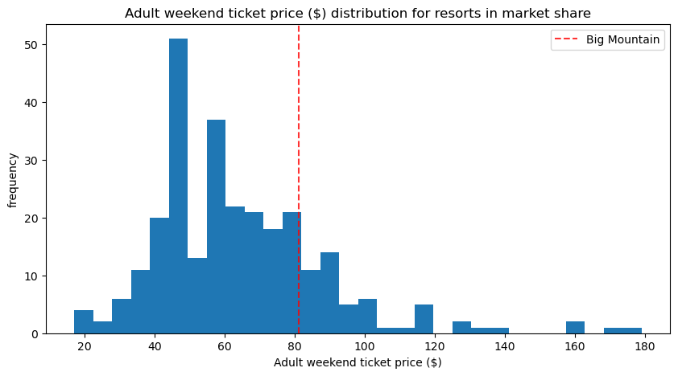

Figure 1. Frequency of adult weekend ticket prices across all resorts.

Figure 2. Relative importance of features as drivers of ticket price from the random forest model.

The business has shortlisted several options for increasing revenue:

1. Permanently closing down up to 10 of the least used runs. This doesn't impact any other resort statistics.
2. Increase the vertical drop by adding a run to a point 150 feet lower down but requiring the installation of an additional chair lift to bring skiers back up, without additional snow making coverage.
3. Same as number 2, but adding 2 acres of snow making cover.
4. Increase the longest run by 0.2 mile to boast 3.5 miles length, requiring an additional snow making coverage of 4 acres.

Of the four scenarios tested, the best outcome was for increasing the vertical drop by adding a run to a point 150 feet lower down (scenario 2). This scenario increases support for ticket price by $1.99. Over the season, this could be expected to amount to $3,474,638 in increased revenue. There would be the cost of installation and operating costs of an additional chair, since this scenario would require the installation of a chairlift to bring skiers back up. Given that the last chair installed increased operating costs by $1,540,000 for the season, this would still be a substantial net gain in revenue.

A second possibility is permanently closing down the least used runs to decrease operating costs (scenario 1). The model shows that if Big Mountain closes down 3 runs, it may as well close down 4 or 5 as there's no further loss in ticket price (see Fig. 3). Closing runs would decrease operating costs but would also lead to support for decreased ticket prices and therefore decreased revenue. If the business could estimate the amount of cost reduction from shutting down a run, we could better assess whether shutting down several trails is worth pursuing.

Figure 3. Decrease in ticket price (left) and revenue (right) from closing between 1-10 runs.

Based on the modeling, I would recommend moving forward with scenario 2, but would also recommend considering the decreased operational costs of shutting down runs. One other point to note is that while Big Mountain's current ticket price is well below the modeled price, its ticket price is on the very high end for Montana resorts. Would Montana residents be willing to pay more, even with added facility benefits? Big Mountain Resort boasts spectacular views of Glacier National Park, over 100 trails, and a vertical drop of 2,353 ft; if visitors are made aware of these alluring features, then an increase in ticket price would be a good way to increase revenue.